Testing Report: ACME Starters B, G0-66
In this report we show all the testing that has taken place in our project, including but not limited to End to End testing, performance testing and stress testing:

End to End testing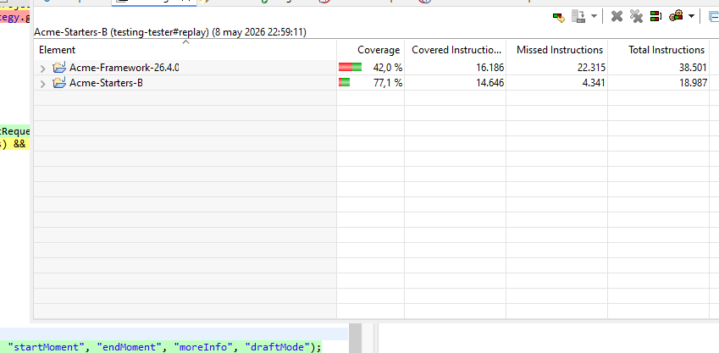:
We have achieved a 77,1% coverage with end to end testing, being divided into modules separated by role and responsibilities. 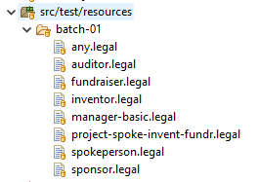
This has allowed us to quickly test that adding new features didn’t introduce any breaking changes to previously working features, which has been especially useful in this level of the project.

Performance logs:
Using these testing files, we have managed to get a lot of useful data that we have compiled in the attached excel spreadsheet. Organizing the thousands of data lines we have managed to get the following 2D graph that shows the relative performance of the different parts of the project:

Software and Hardware profiling:
Furthermore, with further testing we have managed to get more detailed analysis and reports on the strain that our project puts on our machines. This has been extremely useful for making sure there weren’t any hidden bottlenecks and the results of the testing can be seen in the attached images, the first being software and the second hardware.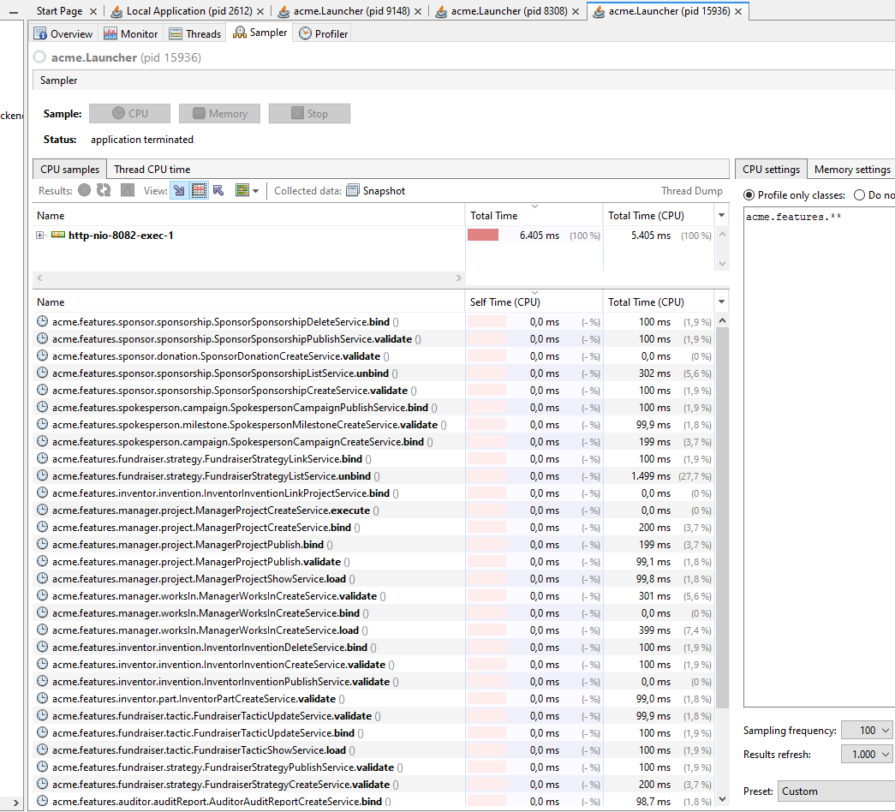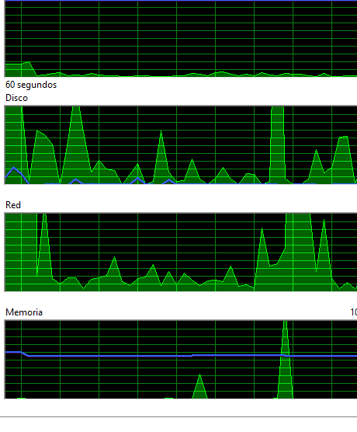

Conclusions:
As we can see, our testing is far from complete but it gives us enough information as to say with confidence that there are no obvious bottlenecks in our projects. Still, we must put effort into continuing this testing in the future to assure the quality of our software. This has been a great learning experience that we will continue to improve upon.

